# LAB 6: Practical Harmonic Analysis

**THEORY:** In the absence of analytical expression for the function *f(x)*, the process of finding Fourier coefficients from the table of function values corresponding to some equidistant points numerically is called the practical harmonic analysis.

Let *y = f(x)* in (0, 2π), then Fourier series will be of the form

$$y=\frac{a_{0}}{2}+\sum_{n=1}^{∞}{a_{n}\cos{nx+\sum_{n=1}^{∞}{b_{n}\sin{nx}}}}$$

where the Fourier coefficients are given by

$$a_{0}=\frac{1}{π}\int_{c}^{c+2π}{f\left(x\right)dx}, a_{n}=\frac{1}{π}\int_{c}^{c+2π}{f(x)\cos{nx dx}}, b_{n}=\frac{1}{π}\int_{c}^{c+2π}{f\left(x\right)\sin{nx dx}}.$$

The term $\frac{a_{0}}{2}$ is called the constant term and the groups of terms (*a1* cos *x* + *b1* sin *x*),

(*a2* cos 2*x* + *b2* sin 2*x*) etc are called the first harmonic, second harmonic, etc respectively. Let *x0*=0, *x1...................xm =* 2π be *m* equidistant points. Then using mean value theorem and trapezoidal rule for integration, numerically approximation for the Fourier coefficients is given by

$$a_{0}=\frac{2}{m}\sum_{r=0}^{m-1}{y_{r}} , a_{n}=\frac{2}{m}\sum_{r=0}^{m-1}{y_{r}\cos{nx_{r}}}, b_{n}=\frac{2}{m}\sum_{r=0}^{m-1}{y_{r}\sin{nx_{r}}}$$

The number of ordinates used should not be less than the twice the number of highest harmonic to be found.

If the length of interval i.e. is the period is *T*, i.e. *l =T/*2, then

$$a_{n}=\frac{2}{m}\sum_{r=0}^{m-1}{y_{r}\cos{nπ\frac{x_{r}}{l}}}, b_{n}=\frac{2}{m}\sum_{r=0}^{m-1}{y_{r}\sin{nπ\frac{x_{r}}{l}}}$$

Where *xr*, *r* = 0......*m*, are equidistant points in the interval [0, *l*] with *x0*=0 and *xm*=*m.*So, the working procedure is as follows:

1. Write down the period *y= f(x)*.
2. If the period is 2π, prepare the relavant table alongwith the summations of *y* cos *x ,...*etc. Compute the harmonics.
3. If the period is not 2π, equate it to 2*l* and find *l* and compute summations of *y* cos *θ,*

*y* cos2 *θ,*.........etc where *θ*= π*x/l*.

**Ex. 1:** Analyse harmonically the data given below and express y in Fourier series upto the third harmonic:

|  |  |  |  |  |  |  |  |
| --- | --- | --- | --- | --- | --- | --- | --- |
| x | 0 | π/4 | 2 π /3 | Π | 4 π /3 | 5 π /3 | 2 π |
| y | 1.0 | 1.4 | 1.9 | 1.7 | 1.5 | 1.2 | 1.0 |

**Solution:**

* Since the last value of y is a repetition of the first, only the first six values will be used. Note that for entering π in excel type =pi(), press ENTER.

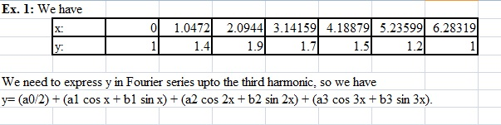

**Fig 6.1.1**

* Clearly the length of the interval is 2π. So, we have

$$a_{0}=\frac{2}{m}\sum_{r=0}^{m-1}{y_{r}} , a_{n}=\frac{2}{m}\sum_{r=0}^{m-1}{y_{r}\cos{nx_{r}}}, b_{n}=\frac{2}{m}\sum_{r=0}^{m-1}{y_{r}\sin{nx_{r}}}$$

Hence, we need to find the values of cos x, cos 2x, cos 3x, sin x, sin 2x and sin 3x.

* First column, under the heading x, type first 5 values of x
* Next type first 5 values of y under the heading y.
* In column 3, give heading as cos x. To compute cos, COS() and for sin, SIN() are the functions. Below it type =COS(value of x), press ENTER. Then drag till next 4 rows. Then the cos values will be evaluated for the entire column. Similarly, make columns of sin x, cos 2x, sin 2x, cos 3x, sin 3x and repeat the procedure. Select the table and right click. Choose format cells, in numbers, fix decimal points upto 4 digits. The table so obtained is shown in the Fig 6.1.2

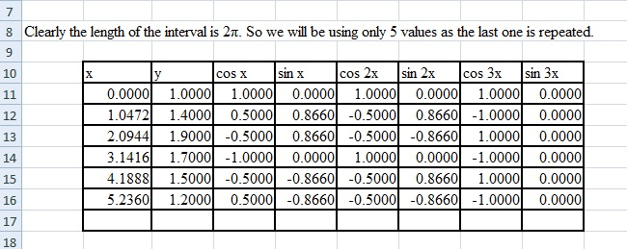

**Fig 6.1.2**

* Compute *a0* by typing =(2/6)*SUM(select all values of y), press ENTER.
* Compute *a1* by typing =(2/6)*MMULT(TRANSPOSE(select all values of y),select all values of cos x), press CTRL+SHIFT+ENTER.
* Compute *a2* by typing =(2/6)*MMULT(TRANSPOSE(select all values of y),select all values of cos 2x), press CTRL+SHIFT+ENTER.
* Compute *a3* by typing =(2/6)*MMULT(TRANSPOSE(select all values of y),select all values of cos 3x), press CTRL+SHIFT+ENTER.
* Compute *a0/2* by typing =(select value of *a0*)/2, press ENTER.
* Compute *b1* by typing =(2/6)*MMULT(TRANSPOSE(select all values of y),select all values of sin x), press CTRL+SHIFT+ENTER.
* Compute *b2* by typing =(2/6)*MMULT(TRANSPOSE(select all values of y),select all values of sin 2x), press CTRL+SHIFT+ENTER.
* Compute *b3* by typing =(2/6)*MMULT(TRANSPOSE(select all values of y),select all values of sin 3x), press CTRL+SHIFT+ENTER.
* Select all the values computed and right click. Then select format cells. In that numbers, fix the decimal upto 4 places.
* 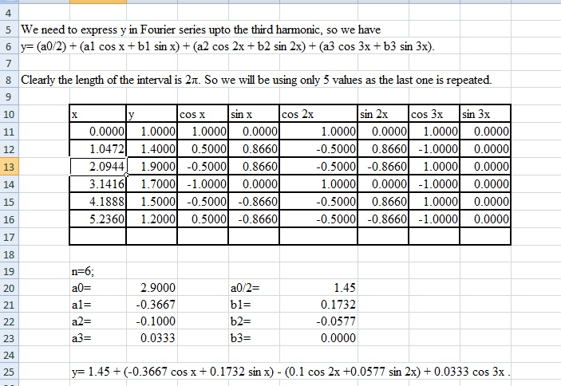Substitute the values in Fourier series expansion and get the answer.

**Fig 6.1.3**

**Ex. 2:** The displacement y of a part of mechanism is tabulated with corresponding angular movement xo of the crank. Express y as a Fourier series neglecting the harmonics above the third.

|  |  |  |  |  |  |  |  |  |  |  |  |  |
| --- | --- | --- | --- | --- | --- | --- | --- | --- | --- | --- | --- | --- |
| xo | 0 | 30 | 60 | 90 | 120 | 150 | 180 | 210 | 280 | 270 | 300 | 320 |
| y | 1.80 | 1.10 | 0.30 | 0.16 | 0.50 | 1.30 | 2.16 | 1.25 | 1.30 | 1.52 | 1.76 | 2.00 |

**Ex. 3:** The following table gives the variations of periodic current over a period:

|  |  |  |  |  |  |  |  |
| --- | --- | --- | --- | --- | --- | --- | --- |
| t(secs) | 0 | T/6 | T/3 | T/2 | 2T/3 | 5T/6 | T |
| A(amp.) | 1.98 | 1.30 | 1.05 | 1.30 | -0.88 | -0.25 | 1.98 |

Show, by numerical analysis, that there is a direct current part of 0.75 amp in the variable current and obtain the amplitude of the first harmonic.

(Note: (*a0/2*) represents the direct current part.

√(*a12+b12)* gives the amplitude.)